**AO10 Assignment- Concept Sketches**

**Homeless Shelter**

**Group L: Portifize**

1. **Process description**

Our strategy for coming up with various designs was to each come up with a design individually and to then share our ideas with each other and discuss the pros and cons of each idea. We used idea creation technique number 3, drawing, to sketch each of our ideas to share so we could better communicate the features and styles of our designs.

1. **Brainstorming results**

After evaluating each drawing the group decided to incorporate regular straps similar to backpacks out on the current market, because it would exemplify to be the most comfortable while also getting the job of portability done as well. We then discussed the mechanism on how the backpack would stay collapsed, and after conversing about this topic the team opted to incorporate a zipper and a sinch tie along the sides of a backpack in order to have the backpack stay collapsed when it is in that position. We then moved on to the overall shape of the tent and were debating between a dome shape and a rectangular shape. In the end the team referenced the focus groups, where both the camping market and homeless market preferred to have more space in the shelter so they don't feel cramped. Due to this, the team believes that the best shelter design to accommodate this need would be a rectangular shape. In addition to picking the design to be rectangular the team also talked about incorporating windows in order to provide a more spacious feeling as well as a measure of protection that both markets can see what is going on outside of their shelter.

1. **Evidence & Revised user needs**

Our team generated these ideas with our most important user needs in mind: portability, convenience, long-term reusability, and safety. Our goal in generating and discussing potential design options was to optimize each of these characteristics in the product. For example, the way the tent collapses is an important decision we had to make. One idea we generated was to have the tent be rectangular and collapse like an accordion. Another idea was to design the tent as a dome and have it fold in half to collapse it. The shape of the tent was important because the way in which the tent fold affects the portability of the product. We decided against the dome shaped design because it would be too big to comfortably carry around on public transportation. We also discussed whether we wanted to use a rectangular spring for collapsing and expanding the tent. By using a spring, the tent would automatically expand with little to no effort from the user. We briefly talked about designs that would require the user to manually set up the tent, but decided against it so we could better address the user’s need for convenience. We want the product to be simple and easy to set up and use, which is best accomplished by a spring rather than other designs. Our group also wants to incorporate sustainable materials into the design, but had to decide which features of the tent would best be suited for those materials. After discussion, we are not going to be using sustainable plastic for the structural frame of the tent, and will opt for metal instead. We didn’t want to negatively affect the long-term reusability of the product by compromising the strength of the spring. Instead, we decided to use environmentally friendly materials for the canvas/tarp material on the outside of the tent. Another user need we want to address is safety. We want to incorporate windows in the final design to allow the user a clear view of their surroundings to prevent users from feeling confined and unsafe. The only changes to our user needs that have been made thus far is the addition of safety. Our user needs have not changed thus far. During our research analysis, we identified the main frustrations and desires in our user base. These desires matched up with the user needs we identified earlier in the problem definition process, so we have not changed our need chart.

**The Designs:**

1. Leah’s Square Spring Design:

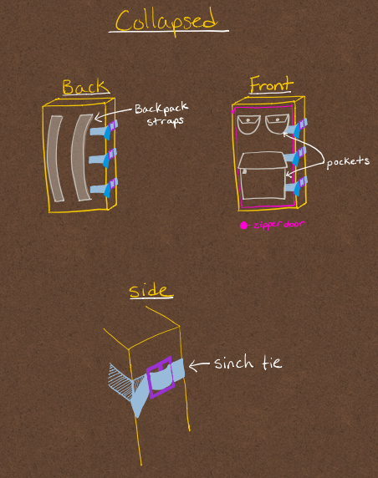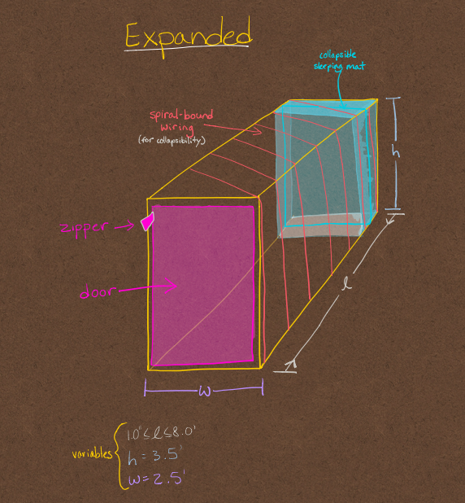

Highlights of design:

* Rectangular spring wound around inside surfaces of tent for easy collapsibility
* Sinch ties to hold the tent together while it is in its backpack form
* Pockets on the outside for storage convenience
* Backpack straps on the back for comfort and portability

1. Avi’s Design:

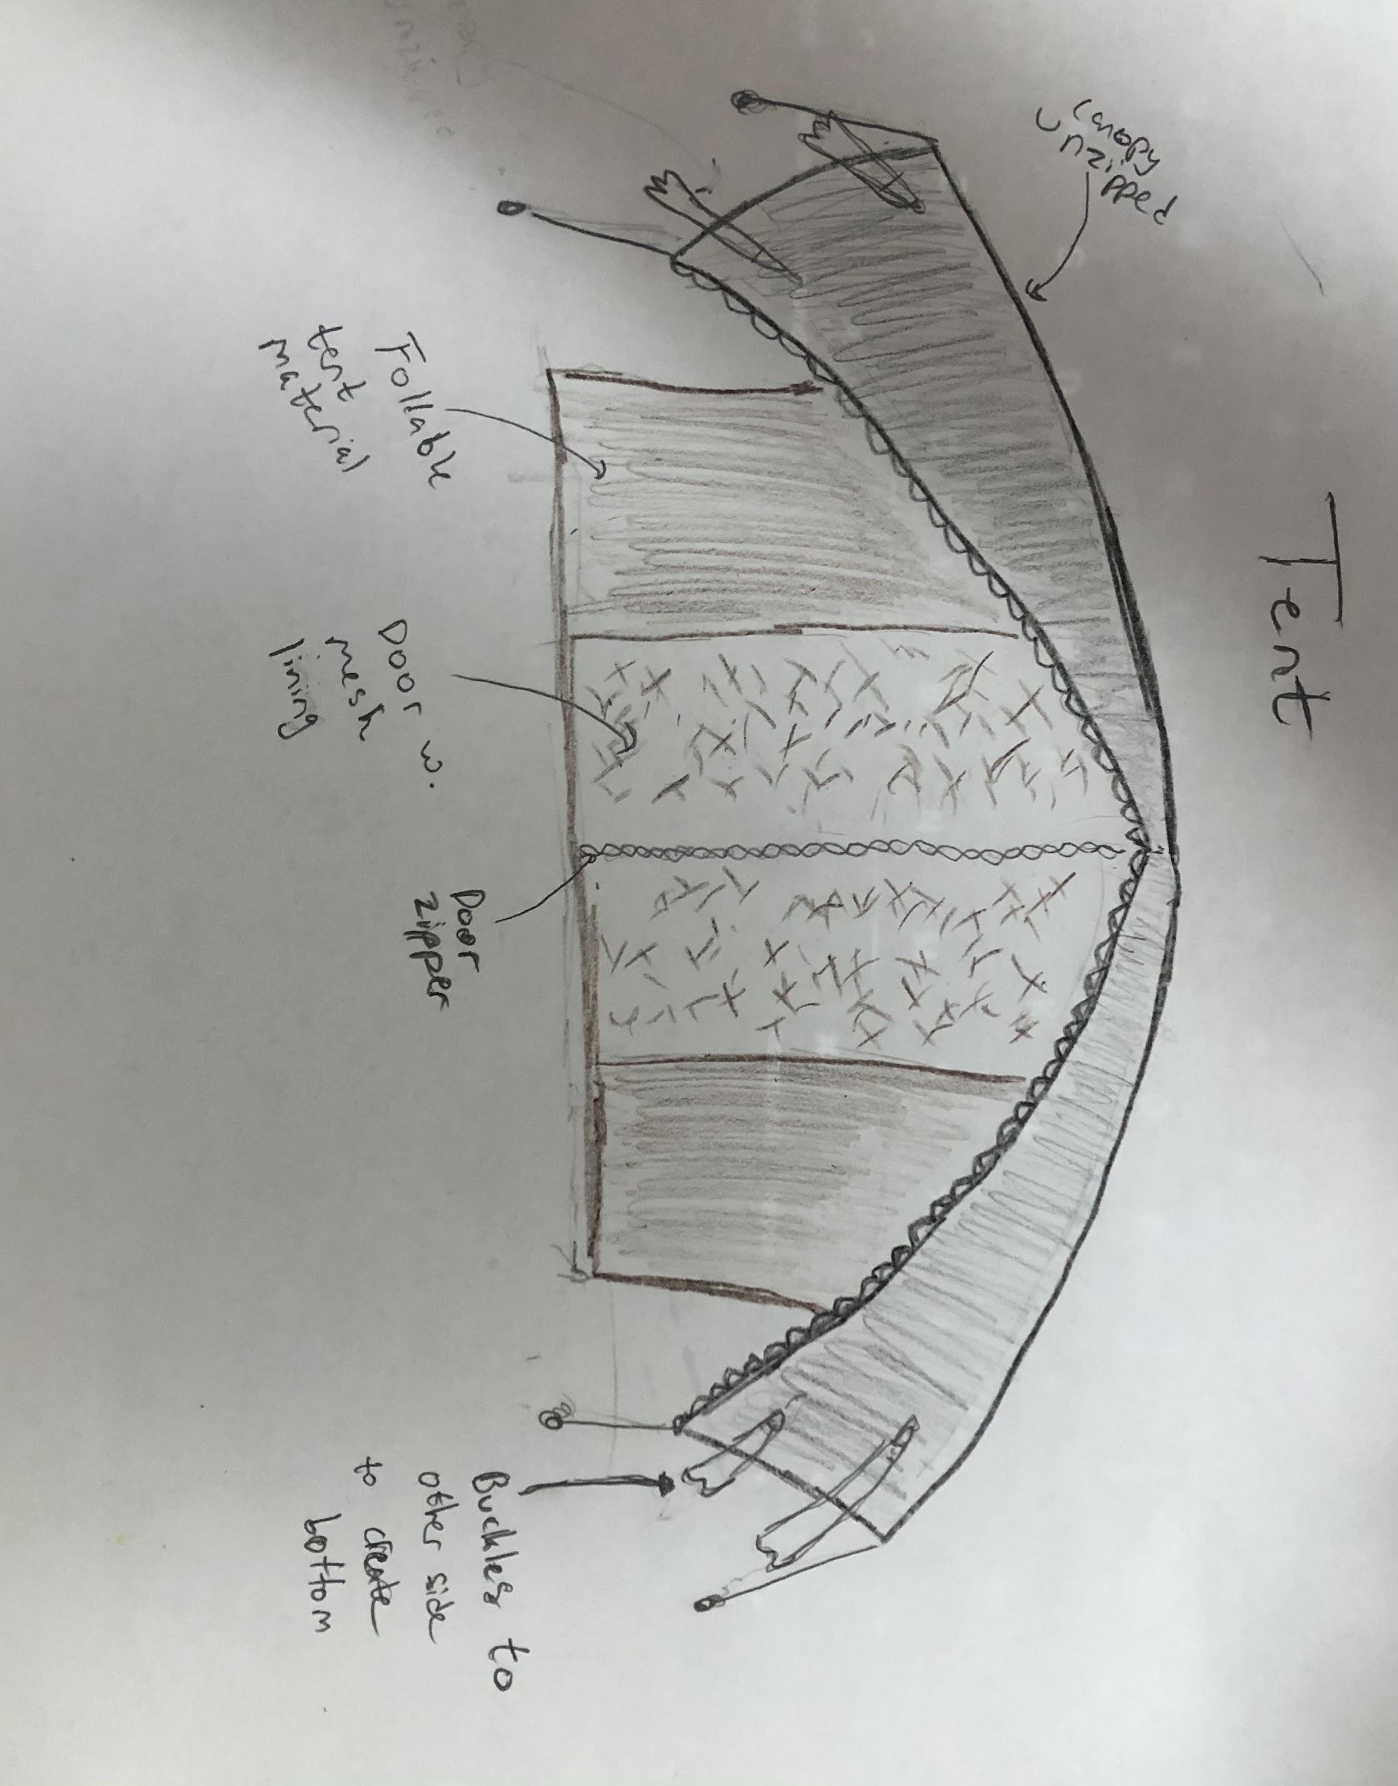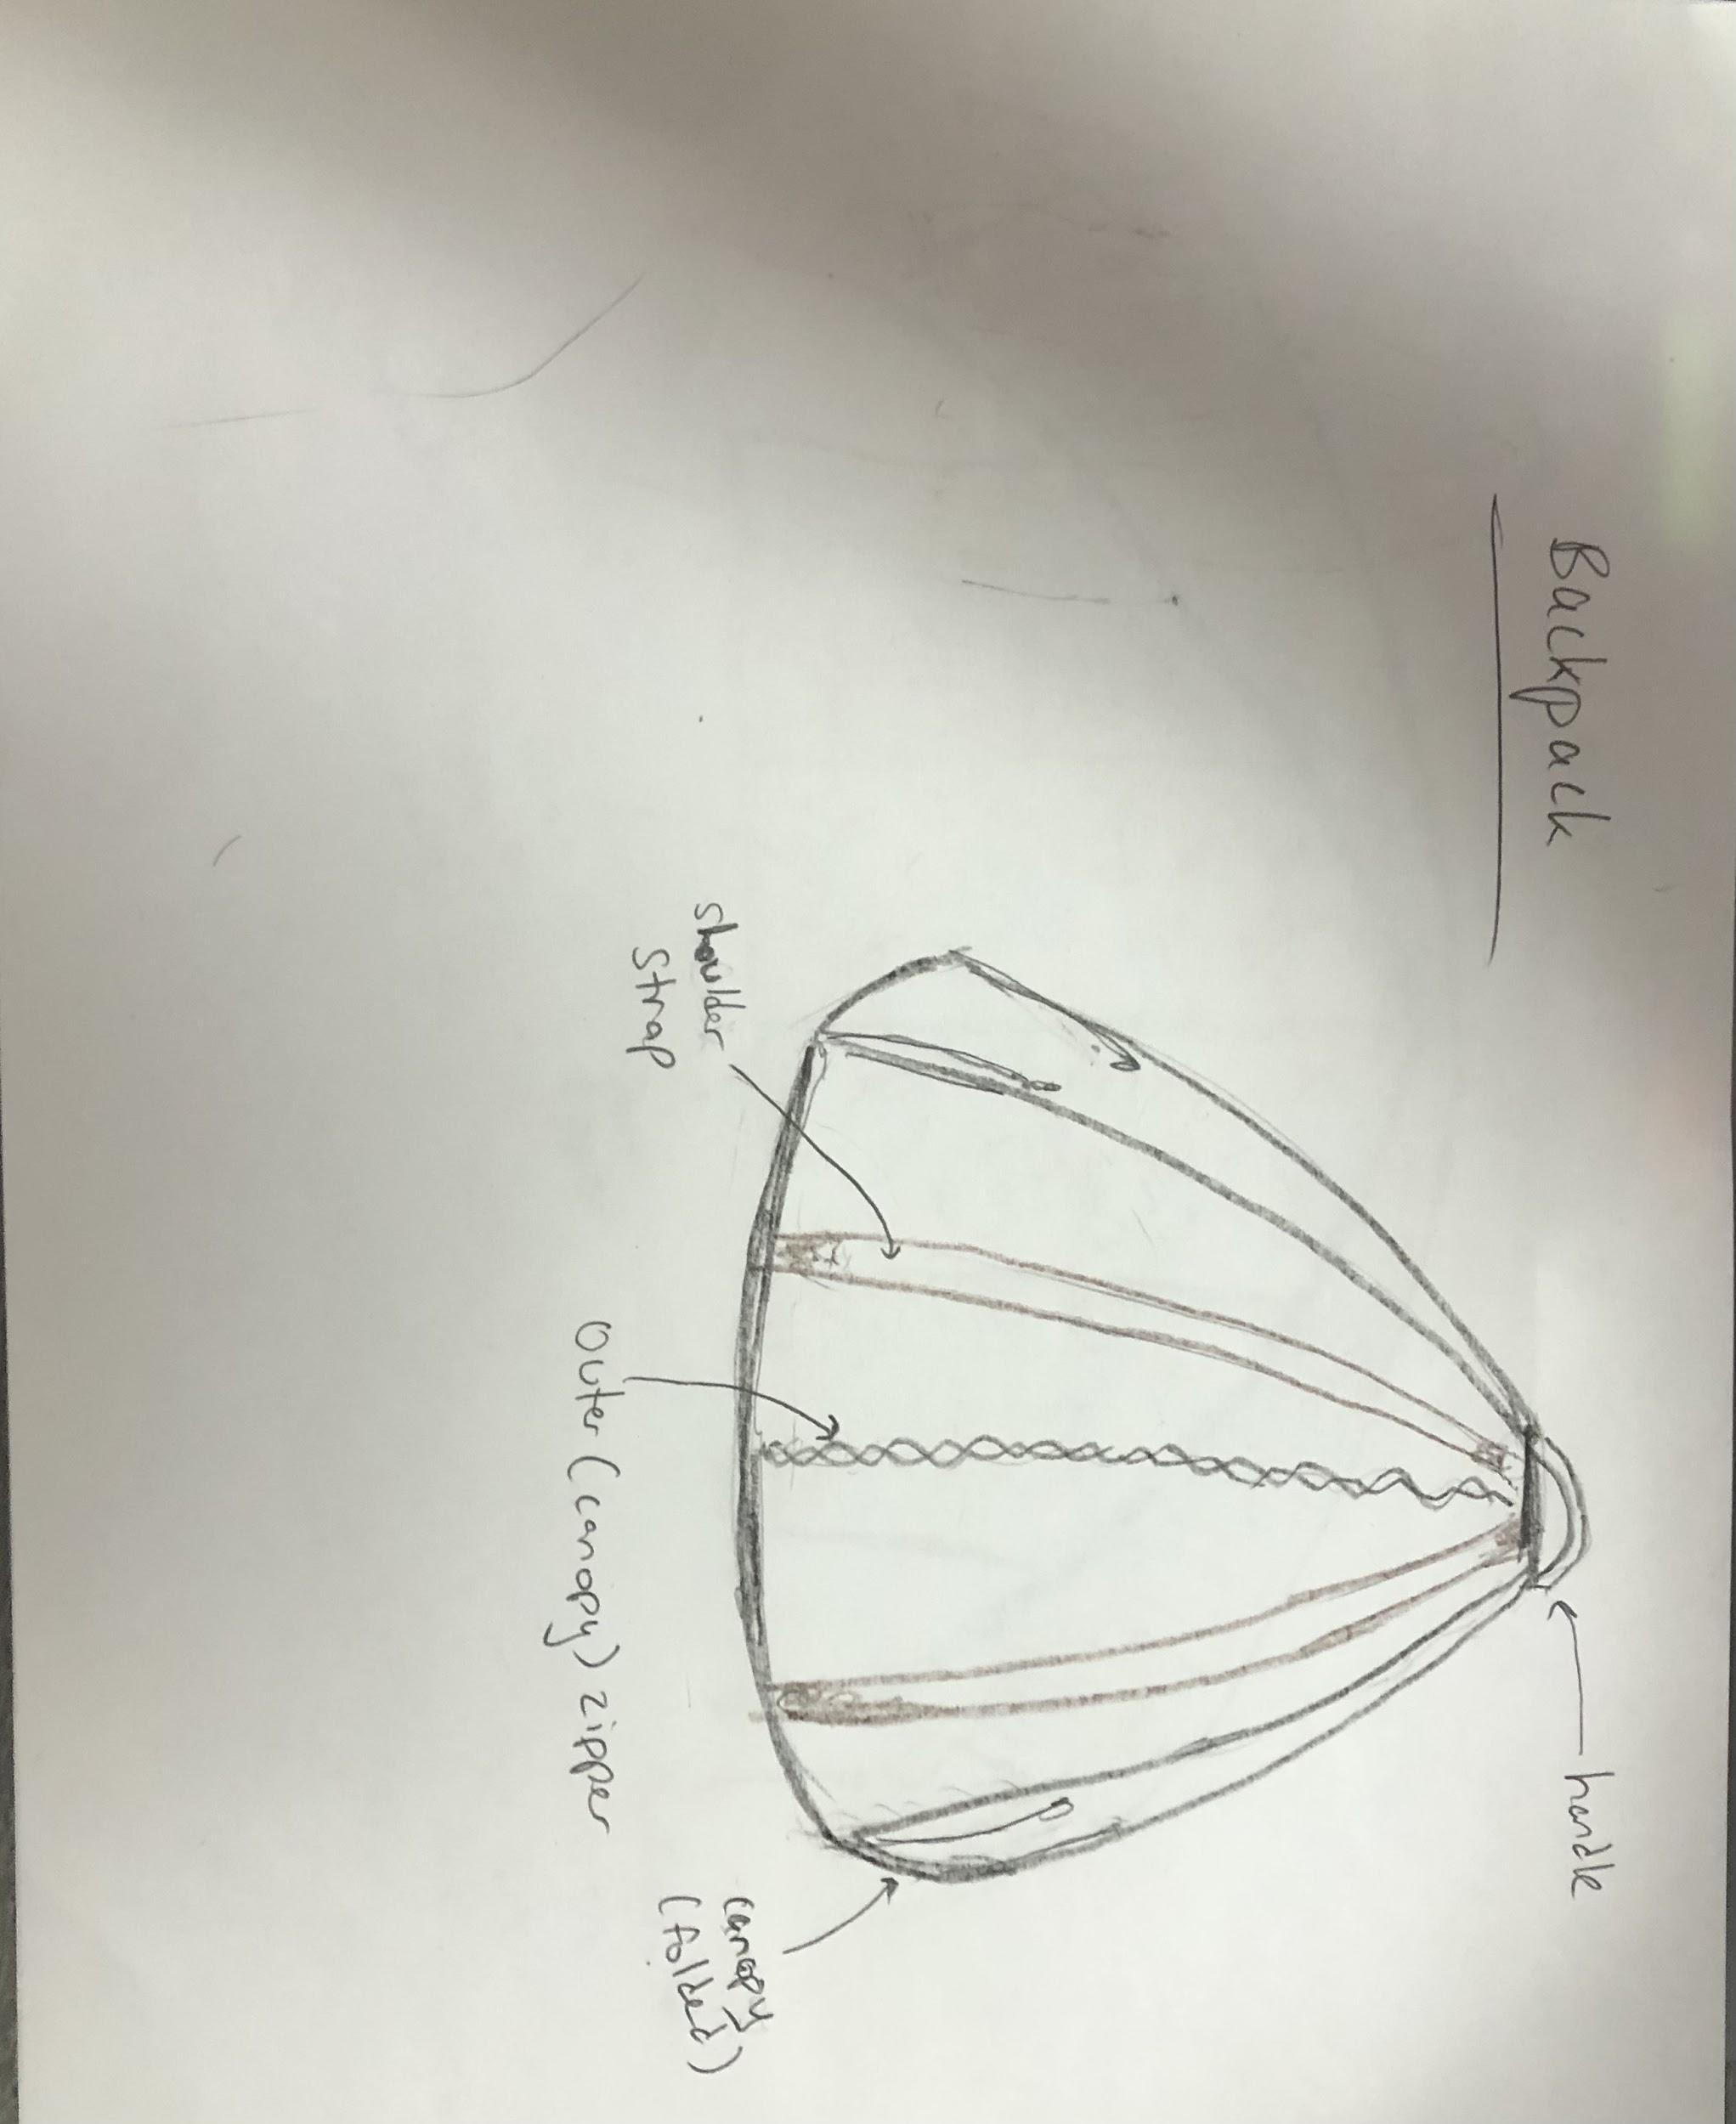

Highlights of design:

* Double zipper and belt buckle functionality
* Canopy on top that zips to form outside of backpack
* Tent and backpack take more of dome shape
* Foldable material + mesh lining near door zipper to create tent area
* Belt buckle attaches canopy at bottom to create bottom of backpack
* Has backpack straps

1. Ashwin’s Design:

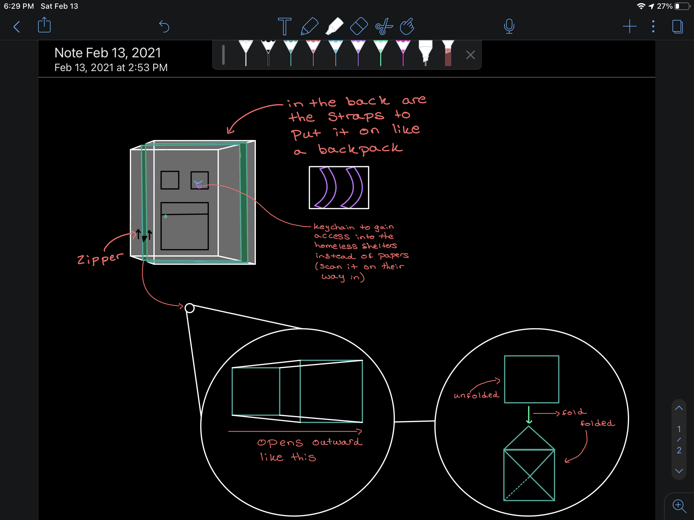

Highlights of the design:

* The keychain to replace the need for papers when entering a homeless shelter.
* The accordion type closing and opening mechanism (powered by unzipping and zipping a zipper).
* The design when folded: Inspired by the beginning folds of an origami water balloon.

1. Ella’s Design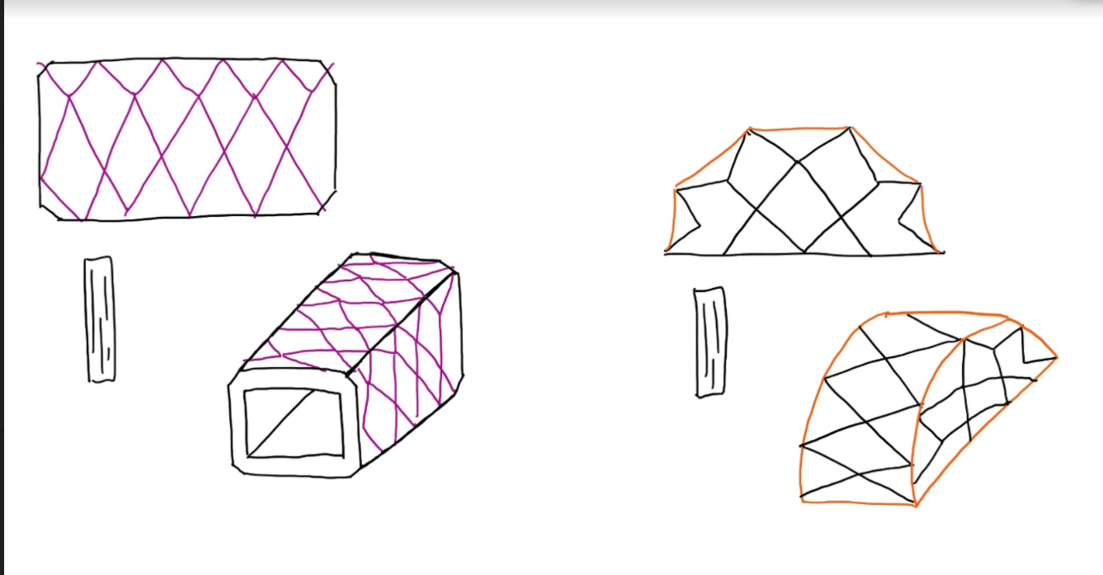

Highlights of design:

* Dome shaped tent design can be folded in half
* Rectangular shaped design can be collapsed accordion style

**4) Appendix**

| **AO10 Assignment** | | | |
| --- | --- | --- | --- |
| **Project Manager for Assignment** | | | |
| Avi Popat | | | |
| **Deputy Manager for Assignment** | | | |
| Ella Wulforst | | | |
| **Drafted Assignment** | **Reviewed Assignment** | **Revised Assignment** | **Proofread Assignment** |
| Avi Popat | Leah Norton | Ashwin Rajkumar | Ella Wulforst |
| **Created Figures** | | **Created Tables** | |
| Everyone | | Ashwin Rajkumar | |
| **Other Contributions** | | | |
| N/A | | | |
| **Problems Overcome** | | | |
| N/A | | | |